Waste Management Plan and the Center for Separation of Recyclable Waste in Lezha

***Summary of the project***

In 2011, Municipality of Lezha was declared the winner of a grant fund by dldp for co-financing the project "*Development of waste management plan and construction of the separation and recycling center in the Municipality of Lezha*". The project managed to harmonize the efforts and combine funding with another support; "*Participatory Plastic Cleaning up and waste management in municipality Lezha*" funded by the Dutch Embassy in Albania in the framework of the MATRA program. The results of the project contribute to the implementation of the *National Strategy on Waste*.

The project's main activities are:

**Developing a plan for management for solid waste in Lezha municipality,** based on the management of performance which is focused on service outcomes.

**Building Separation and Recycling Center.** Thedestination of the center is the service for separation of recyclable waste, collected separately at source. With its establishment the Municipality reduces the quantity of inorganic recyclable waste in the landfill (at the beginning paper and plastic), which can be used to promote and develop the recycling industry in the country.

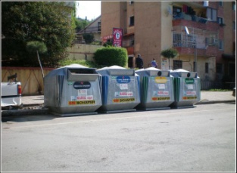 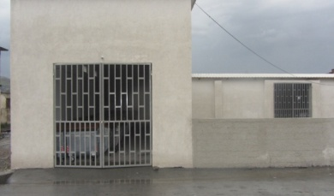

**Name of the project:** Waste Management Plan and the center for separation of recyclables waste in the Municipality of Lezha

**Donor:** Swiss Agency for Development and Cooperation (SDC)

**Duration**

February 2011-March 2012

**Swiss contribution (through dldp):** 39540 Euro

Municipality contribution: 9800 Euro

**Beneficiaries**

Municipality of Lezha

AAR (Albanian Association of Recyclers)

**Technical assistance**

URI (Urban Research Institute)

**Results of the project**

Waste management plan elaborated

Feasibility study for the Recyclables Waste Separation Center (RWSC) done

Center for separate waste collection reconstructed and equipped

### 

### Objectives of municipality for waste management

**1.Waste collection based on two streams (paper and plastic)**

Year III: In Zones A+B+C or in 100% of households, the waste is collected separately

Year II: In Zone A+B or in 81% of households, the waste is collected separately

Year I: In Zone A or in 46% of households, the waste is collected separately

**2. Construction of RWSC for recycling of wastes (paper and plastic)**

Year I: 17% of waste weight is prepared for recycling in RWSC

Year II: 30% of waste weight is prepared for recycling in RWSC

Year 3: 37 % of waste weight is prepared for recycling in RWSC

**3. Reduction of waste deposited at Bushat landfill**

Year 3: 63% of waste is deposited in landfill of Bushat

Year 2: 70% of waste is deposited in landfill of Bushat

Year I: 83% of waste is deposited in landfill of Bushat